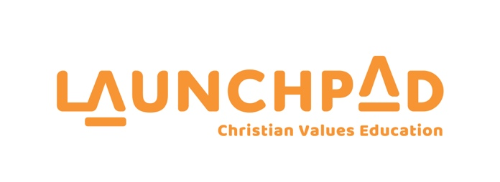

CHURCHES EDUCATION COMMISSION REPORT
TO THE GENERAL SYNOD / TE HĪNOTA WHĀNUI 2019/2020

Introduction from CEO – Geoff Burton

The role as CEO of Launchpad began for me in November 2018, I took over the leadership of the organisation from Stephanie Sewell.

I have a background in marketing and worked for TVNZ for many years prior to accepting this new appointment. In saying this, my journey with Churches Education Commission began many years earlier as a presenter for 9 years in my local school.

I hit the ground running with the first task being the rebranding of the entire organization. A worthwhile and busy venture! The year of 2019 had it’s many challenges but also some great outcomes for Launchpad.

Rebrand

After months of discussion, we believed the name CEC (Bible In Schools) no longer fully represented us, it had become outdated and was no longer relevant for school communities.

We needed a name children could use, get excited about and relate to as this would allow us to approach schools with a fresh image and vision.

Before going public with the brand, Geoff and the team travelled throughout the country bringing the new brand story to all our presenters and teams across all our regions.

After much preparation and groundwork, we revealed our new brand name and image at our Fundraising event in Auckland on June 29, 2019 at Sorrento, Cornwall Park

Following the reveal of Launchpad at this event, we set about implementing our new brand elements across the organisation and in school and church communications.
The feedback was really encouraging.
Court Case

The High Court case was brought by members of The Secular Education Network (SEN) against the Crown. The case had been pending over a 5 year period and sought the removal of any religious presence in NZ State primary schools. This included the work of Launchpad, chaplaincy and all religious observances like Karakia, Bible readings and discussion on topics like Christmas and Easter.

As the main provider of Religous Instruction in NZ primary schools Launchpad was granted an intervenor status in the case. This allowed us to provide evidence and have legal representation in Court.

As the Court-case and related media focus heated up it became very clear that this case had the potential to end everything we do, it became clear, we needed the best legal representation to face this threat, and at that time we didn’t have it.

To address this, we appointed Grant Illingworth QC who is one of the most experienced and respected QCs in the country.

Grant also had the advantage of being a Christian and had a long legal history with the lawyers for the Crown who he needed to work closely with in the preparation of the evidence for the defence. Grant did an incredible job working with us over a period of weeks to review and gather evidence. We also worked closely with the lawyers for the Crown, including taking them to many schools to view Launchpad sessions.

The case was set to commence in the Auckland High Court on October 12, 2020.

A few weeks before the first day in Court we were informed that the lawyers for the plantif had advised their client (SEN) that upon the disclosure of evidence for the defence (the Crown and Launchpad) they couldn’t possibly win the case, and the plantiff miracously withdrew directly before the case was about to be heard.

Curriculum Revision

Our curriculum undergoes constant revision due to the 3 year curriculum cycle that we have created. Our curriculum is recognised by colour, Orange, Purple and Green.

Our presenters provide regular feedback on the curriculum as they use it in situ in schools. We try to review this feedback and implement changes as needed.

Our National Advisor is responsible for leading this process. We are planning to integrate the upcoming rebrand elements across the curriculum.

Promotional Video

With the reveal of the new Launchpad brand mid 2019 it was the perfect opportunity to bring the brand to life in a promotional video.

This project required a lot of pre-production time in finding the right partner who could deliver the essence of our brand. Our search ended with Craig Henderson at Symphony. Craig played a key leadership role in the Young Ocean Explorers project which has been rolled out in primary schools throughout New Zealand. We filmed the promotional video in September 2020.

Our star, Micaiah Samuela, had literally turned 5 and started school two days before the shoot. We knew the decision to cast Micaiah was a risk with her being so young but her casting video showed her inner spark and fortunately the risk paid off!

The video has had huge applause and we believe it very succinctly captures the essence of what Launchpad is all about.

www.launchpad.kiwi to check out the video

Summation

Launchpad has continued to be strong with our programme in 420 schools delivered by over a thousand volunteer presenters in 16 regions.

With the unexpected circumstances of COVID-19, we have had to navigate the challenge of not being able to be in schools as normal. We sent out Smile Boxes to all our Launchpad school Principals to let them know that their school communities were on our minds given the unique position our country was in.

One of our lessons that we take into schools is the story of Gladys Aylward, an English woman who had a passion for the people of China. She left everything she knew with all the resources she had to travel thousands of miles, in treacherous conditions during a world war to get to China. The circumstances she continued to face were extreme, but she never gave up. Gladys Aylward adopted and saved over 100 Chinese children and brought them to safety through mountain ranges in the middle of a war.

This account is more than a story for us here at Launchpad as we face the future and all that it brings.

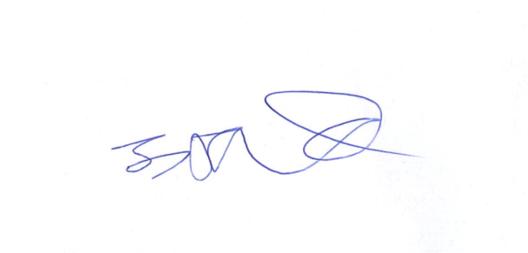

Geoff Burton
CEO - Launchpad

